**iNeuron FSDA Assignment -1**

**TASK 1**

--Task 1

----------

Create table "CSN_INEURON_ASSIGNMENT"."PUBLIC".Shopping_History

(

"product" varchar not null ,

"Quantity" INTEGER ,

"unit_price" INTEGER

)

;

/*

INSERT INTO "CSN_INEURON_ASSIGNMENT"."PUBLIC".Shopping_History

VALUES('',,);

*/

INSERT INTO "CSN_INEURON_ASSIGNMENT"."PUBLIC".Shopping_History

VALUES('Office Chair',2,100);

INSERT INTO "CSN_INEURON_ASSIGNMENT"."PUBLIC".Shopping_History

VALUES('Meeting Table',5,1000 );

INSERT INTO "CSN_INEURON_ASSIGNMENT"."PUBLIC".Shopping_History

VALUES('Single Seat White Sofa',4 ,1500);

INSERT INTO "CSN_INEURON_ASSIGNMENT"."PUBLIC".Shopping_History

VALUES('Single Seat Black Sofa', 4,1100);

INSERT INTO "CSN_INEURON_ASSIGNMENT"."PUBLIC".Shopping_History

VALUES('Mannequin',4, 200);

INSERT INTO "CSN_INEURON_ASSIGNMENT"."PUBLIC".Shopping_History

VALUES('Brouchure Rack',10,300);

INSERT INTO "CSN_INEURON_ASSIGNMENT"."PUBLIC".Shopping_History

VALUES('Plants',5,150);

INSERT INTO "CSN_INEURON_ASSIGNMENT"."PUBLIC".Shopping_History

VALUES('Dustbin',12,50);

INSERT INTO "CSN_INEURON_ASSIGNMENT"."PUBLIC".Shopping_History

VALUES('Double Seat White Sofa',2 ,2500);

INSERT INTO "CSN_INEURON_ASSIGNMENT"."PUBLIC".Shopping_History

VALUES('Double Seat Black Sofa', 3,2100);

INSERT INTO "CSN_INEURON_ASSIGNMENT"."PUBLIC".Shopping_History

VALUES('Meeting Table',2,800 );

INSERT INTO "CSN_INEURON_ASSIGNMENT"."PUBLIC".Shopping_History

VALUES('Single Seat White Sofa',5 ,1200);

INSERT INTO "CSN_INEURON_ASSIGNMENT"."PUBLIC".Shopping_History

VALUES('Single Seat Black Sofa', 2,900);

INSERT INTO "CSN_INEURON_ASSIGNMENT"."PUBLIC".Shopping_History

VALUES('Mannequin',5, 150);

Select * from "CSN_INEURON_ASSIGNMENT"."PUBLIC".Shopping_History;

--Final Query

select "product" , sum("Quantity" * "unit_price" ) "total_price" from "CSN_INEURON_ASSIGNMENT"."PUBLIC".Shopping_History

group by "product";

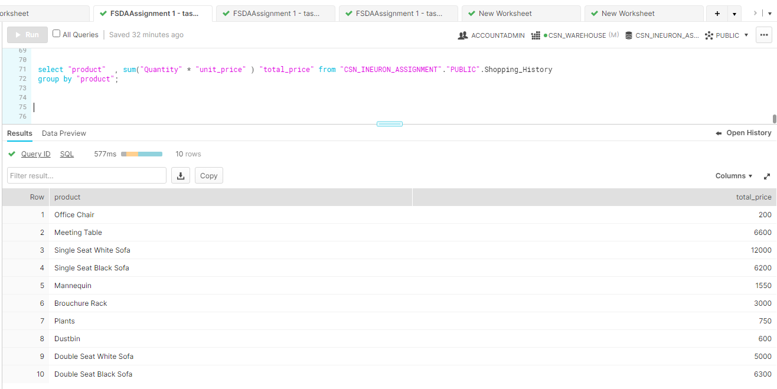

**TASK 2**

--Task 2

CREATE OR REPLACE TABLE "CSN_INEURON_ASSIGNMENT"."PUBLIC".Phones

(

name VARCHAR2(100) not null,

phone_Number INTEGER not null unique

);

CREATE OR REPLACE TABLE "CSN_INEURON_ASSIGNMENT"."PUBLIC".Calls

(

id INTEGER not null,

caller INTEGER not null,

callee INTEGER not null,

duration INTEGER not null,

unique(id)

);

INSERT INTO "CSN_INEURON_ASSIGNMENT"."PUBLIC".Phones

VALUES('Jack',1234);

INSERT INTO "CSN_INEURON_ASSIGNMENT"."PUBLIC".Phones

VALUES('Lena',3333);

INSERT INTO "CSN_INEURON_ASSIGNMENT"."PUBLIC".Phones

VALUES('Mark',9999);

INSERT INTO "CSN_INEURON_ASSIGNMENT"."PUBLIC".Phones

VALUES('Anna',7582);

INSERT INTO "CSN_INEURON_ASSIGNMENT"."PUBLIC".Calls

VALUES(25,1234,7582,8);

INSERT INTO "CSN_INEURON_ASSIGNMENT"."PUBLIC".Calls

VALUES(7,9999,7582,1);

INSERT INTO "CSN_INEURON_ASSIGNMENT"."PUBLIC".Calls

VALUES(18,9999,3333,4);

INSERT INTO "CSN_INEURON_ASSIGNMENT"."PUBLIC".Calls

VALUES(2,7582,3333,3);

INSERT INTO "CSN_INEURON_ASSIGNMENT"."PUBLIC".Calls

VALUES(25,3333,1234,1);

INSERT INTO "CSN_INEURON_ASSIGNMENT"."PUBLIC".Calls

VALUES(25,3333,1234,1);

select * from "CSN_INEURON_ASSIGNMENT"."PUBLIC".Phones;

select * from "CSN_INEURON_ASSIGNMENT"."PUBLIC".Calls;

--final query

select p.name from (

select caller client,duration from "CSN_INEURON_ASSIGNMENT"."PUBLIC".Calls

union all

select callee client,duration from "CSN_INEURON_ASSIGNMENT"."PUBLIC".Calls

) b inner join "CSN_INEURON_ASSIGNMENT"."PUBLIC".Phones p on b.client=p.phone_number group by client, p.name

having sum(duration)>=10 order by p.name

* Query worked for all data tables provided.

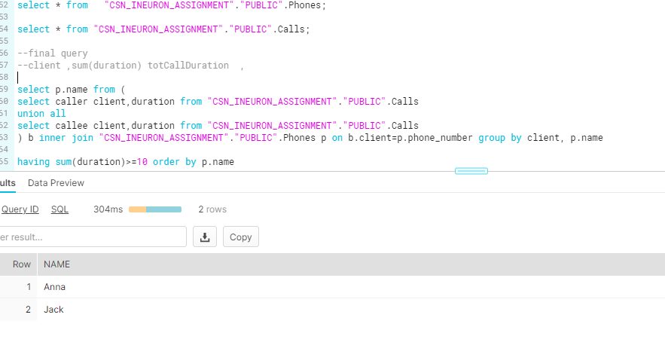

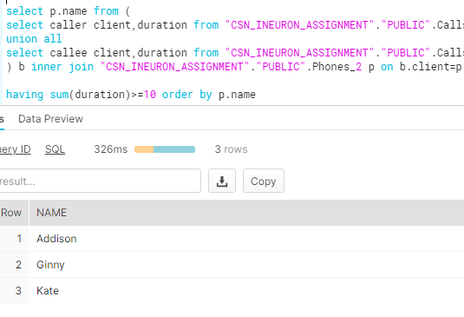

**TASK 3**

CREATE OR REPLACE TABLE "CSN_INEURON_ASSIGNMENT"."PUBLIC". Transactions

(

amount INTEGER not null,

date date not null

);

INSERT INTO Transactions

VALUES(1000,'2020-01-06');

INSERT INTO Transactions

VALUES(-10,'2020-01-14');

INSERT INTO Transactions

VALUES(-75,'2020-01-20');

INSERT INTO Transactions

VALUES(-5,'2020-01-25');

INSERT INTO Transactions

VALUES(-4,'2020-01-29');

INSERT INTO Transactions

VALUES(2000,'2020-03-10');

INSERT INTO Transactions

VALUES(-75,'2020-03-12');

INSERT INTO Transactions

VALUES(-20,'2020-03-15');

INSERT INTO Transactions

VALUES(40,'2020-03-15');

INSERT INTO Transactions

VALUES(-50,'2020-03-17');

INSERT INTO Transactions

VALUES(200,'2020-10-10');

INSERT INTO Transactions

VALUES(-200,'2020-10-10');

select * from Transactions;

select sum(amount) from Transactions;

-- SELECT EXTRACT(MONTH ,date) AS MTH_FROM_DATE from transactions ;

-- select amount,EXTRACT(MONTH ,date) AS MTH_FROM_DATE from Transactions where amount<0 ;

-- select sum(amount),EXTRACT(MONTH ,date) AS MTH_FROM_DATE,count(MTH_FROM_DATE) from Transactions where amount<0 group by EXTRACT(MONTH ,date) ;

-- select sum(amount),EXTRACT(MONTH ,date) AS MTH_FROM_DATE from Transactions where amount<0 group by EXTRACT(MONTH ,date) having count(MTH_FROM_DATE)>=3 and abs( sum(amount))>=100 ;

-- select EXTRACT(MONTH ,date) AS MTH_FROM_DATE from Transactions where amount<0 group by EXTRACT(MONTH ,date) having count(MTH_FROM_DATE)>=3 and abs( sum(amount))>=100 ;

------- final query

select (sum(amount)- (5*(12 -countval) )) balance from transactions,

(select count(b.*) countval from (

select sum(amount),EXTRACT(MONTH ,date) AS MTH_FROM_DATE from Transactions where amount<0 group by EXTRACT(MONTH ,date) having count(MTH_FROM_DATE)>=3 and abs( sum(amount))>=100

) b)c group by countval

* Query worked for all data tables provided.

